**Task 3a - Alteryx Workflows**

**Part 1:**

Task_3-a_Data_Preparation.yxmd

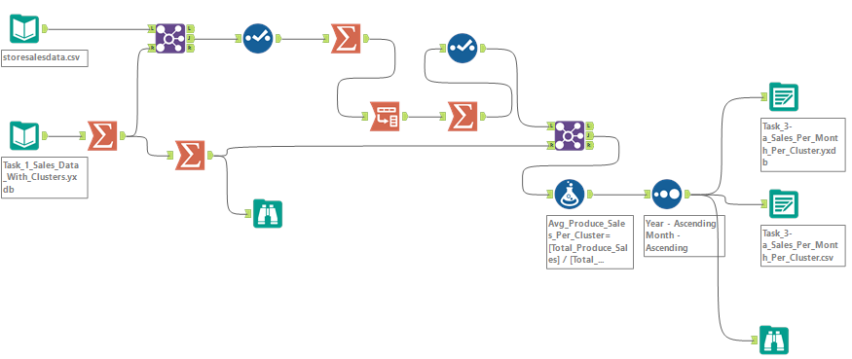

**Part 2:**

Task_3-a_Final_Forecast_Model.yxmd

